ASSIGNMENT 3- Power Query Editor

Name: Padmapriya Palanisamy

* **Use the Employee Details dataset**

*Split the column CITY and separate the code associate with each city like - Allahabad[AL2] should be only Allahabad and [A2] will be separate*

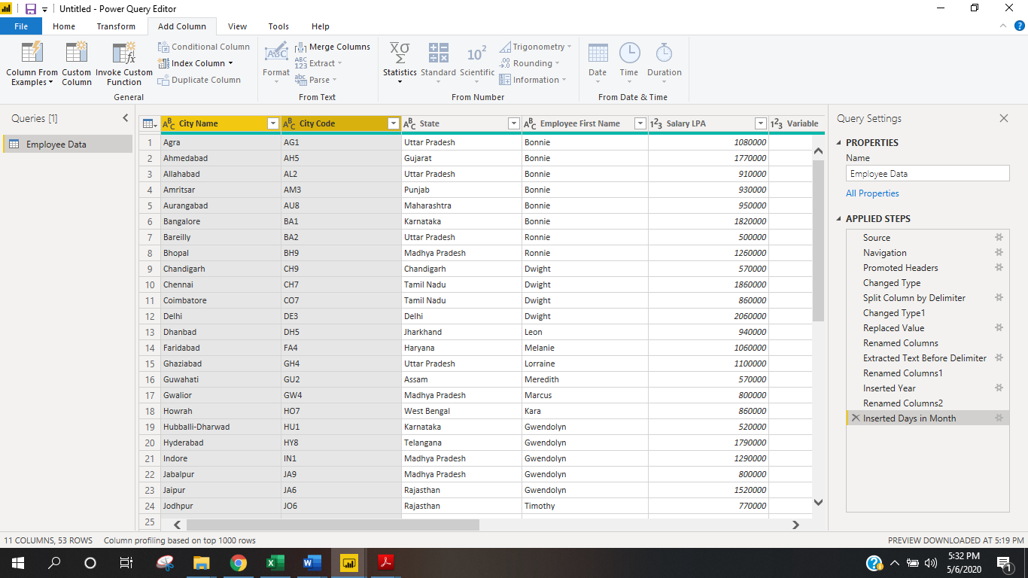

***Extract the first name from EMPLOYEE NAME column and transform the column*** 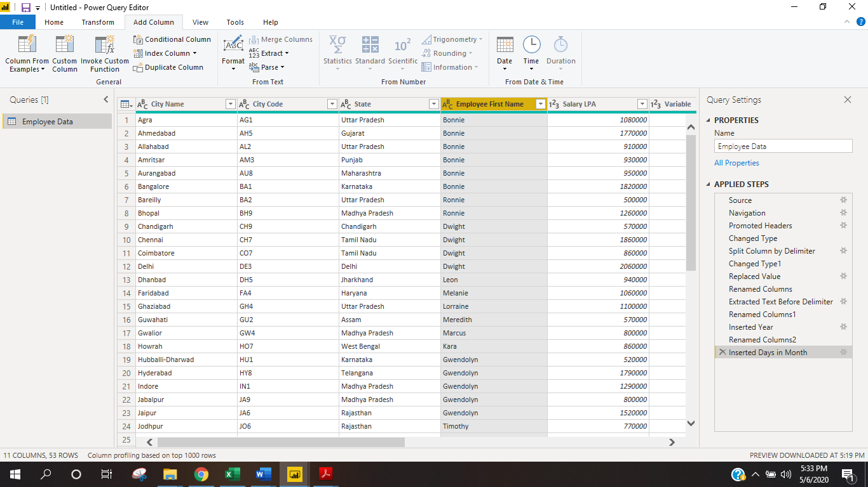

*Using the JOINING DATE column extract the Year and no. of days for that month*

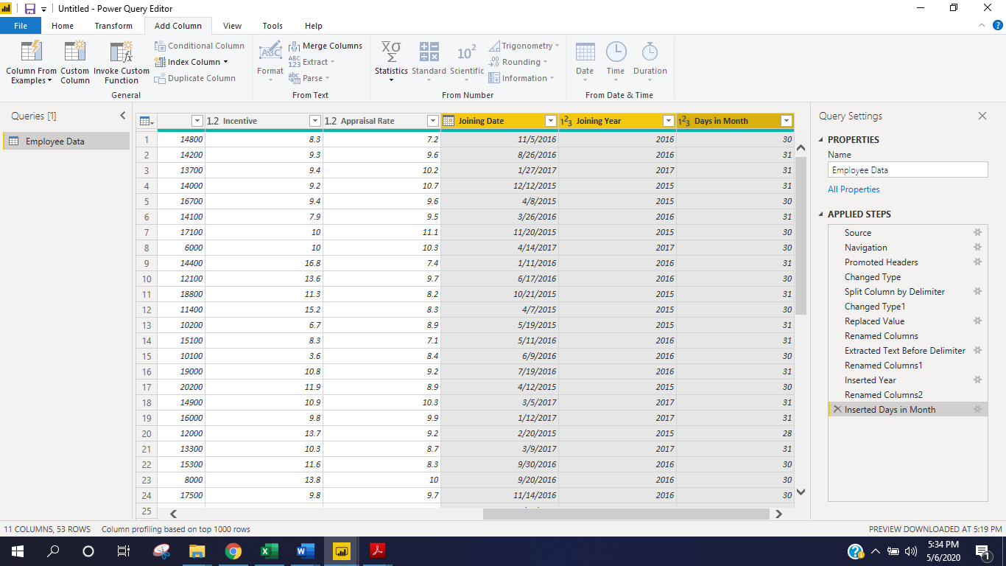

*Create a visual of your choice and show the how much salary has been paid to each state and which state has lowest payout.*

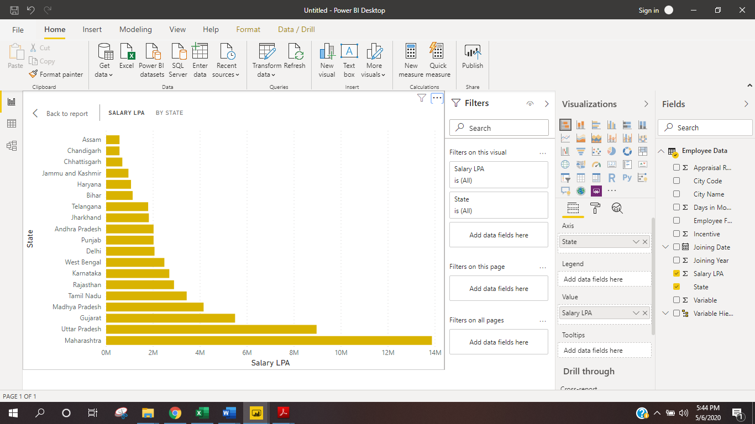

***lowest payout - ASSAM***